Intro to ML 2: Classification

Pre-Workshop Exercises



# What is Machine Learning?

*Q: What are the missing subsystems in the flowchart below?*

*Q: What do those subsystems do?*

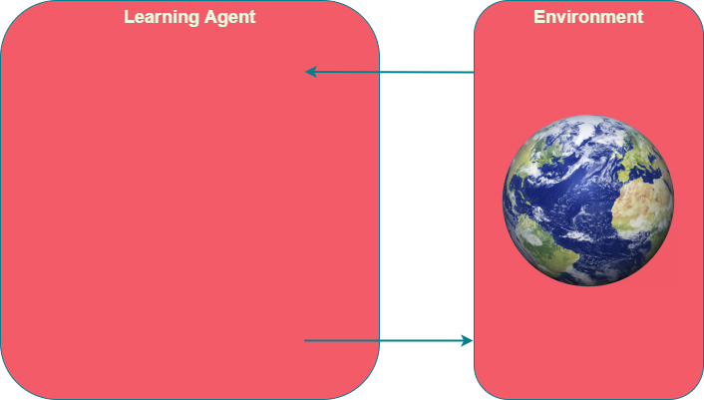

# Types of Machine Learning?

*Q: What are the three main types of machine learning?*

*Q: What was regression about?*

*Q: How is regression different from classification?*

# What are Features?

*Consider an abritrary model below that takes in features and outputs a prediction of whether it is a dog or not. List five features you could use.*

*Rank the weights of the features from highest to lowest. Include whether the weights are positive, zero, or negative.*

Is it a dog?

w1

w2

w3

w4

w5

# What is the Best Fit?

*Consider the graphs below. Which graph shows the best fit and why?*

*Label each graph is a term that represents the fit.*

**HINT**: Use prefixes like “under” and “over”